Web tables:

<http://makeseleniumeasy.com/2017/07/14/how-to-handle-a-web-table-in-selenium-webdriver/>

In this post we will learn:  
1. What is a web table?  
2. Types of web tables.  
2. Creating a demo web table using html.  
3. Print all headers of a web table.  
4. Retrieve and print number of rows in a web table.  
5. Retrieve number of columns for each row.  
6. Retrieve columns based on some conditions.  
7. Retrieve last row of table.  
8. Retrieve cell value using row and column number.  
9. Retrieve column index based on column name.  
10. Print all data from table.

**What is web table?**

A table is made of rows and columns. When we create a table for a web page, that is called as a web table. In HTML, table is created using **<table>** tag. Web table is a HTML structure for creating rows and columns on a Web page.

#### Types of web tables:

We can categorized web tables in two parts:

1. **Static web table:** Number of rows and columns will be definite. Eg. Table of months, Table of days etc.
2. **Dynamic table:** Number of rows and columns will be dynamic. It will be keep on increasing or decreasing based on data. For Eg: Sales table, Student table.

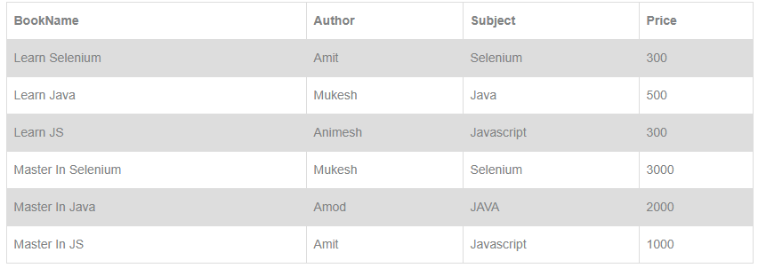

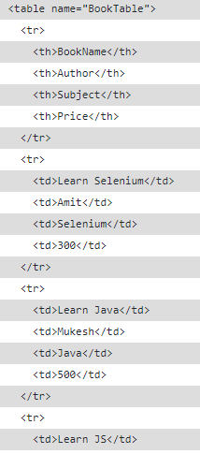

public class HandlingWebTable {

public static void main(String[] args) {

System.out.println("Execution Starts");

// Setting chrome driver property and opening chrome browser

System.setProperty("webdriver.chrome.driver", "./exefiles/chromedriver.exe");

WebDriver driver= new ChromeDriver();

System.out.println("Browser opened.");

// loading URL

driver.get("C:/Users/Amod Mahajan/Desktop/HTMLTable.html");

// Printing table header of a web table assuming first row as header

System.out.println("Printing all header of table assuming first row as header: ");

List allHeadersOfTable= driver.findElements(By.xpath("//table[@name='BookTable']/tbody/tr[1]/th"));

System.out.println("Headers in table are below:");

System.out.println("Total headers found: "+allHeadersOfTable.size());

for(WebElement header:allHeadersOfTable)

{

System.out.println(header.getText());

}

System.out.println("=====================================================================");

// Printing table header of a web table assuming no information about header row

System.out.println("Printing all header of table without information of row header ");

List allHeadersOfTable1= driver.findElements(By.xpath("//table[@name='BookTable']/tbody/tr/th"));

System.out.println("Headers in table are below:");

System.out.println("Total headers found: "+allHeadersOfTable1.size());

for(WebElement header:allHeadersOfTable1)

{

System.out.println(header.getText());

}

System.out.println("=====================================================================");

// Finding number of rows in a web table. We need to exclude header to get actual number of data rows

System.out.println("Retrieving total number of data rows:");

List allRows= driver.findElements(By.xpath("//table[@name='BookTable']/tbody/tr"));

System.out.println("Total data rows found in table:"+ (allRows.size()-1));

System.out.println("=====================================================================");

// Find number of columns in each row

System.out.println("Retrieving total number of columns for each row:");

for(int i=2;i&lt;=allRows.size();i++)

{

List allColumnsInRow=driver.findElements(By.xpath("//table[@name='BookTable']/tbody/tr["+i+"]/td"));

System.out.println("Number of columns in "+(i-1)+" data row is:"+allColumnsInRow.size());

}

System.out.println("=====================================================================");

//Print each rows and columns from web table

System.out.println("Printing all column value: ");

for(int i=2;i&lt;=allRows.size();i++)

{

List allColumnsInRow=driver.findElements(By.xpath("//table[@name='BookTable']/tbody/tr["+i+"]/td"));

for(int j=0;j&lt;allColumnsInRow.size();j++)

{

System.out.print(allColumnsInRow.get(j).getText()+" ");

}

System.out.println();

}

System.out.println("=====================================================================");

// List books name and price whose author is mukesh

System.out.println("Way 1: Books written by Mukesh are below:");

for(int i=2;i&lt;=allRows.size();i++)

{

WebElement authorColumn=driver.findElement(By.xpath("//table[@name='BookTable']/tbody/tr["+i+"]/td[2]"));

if(authorColumn.getText().toLowerCase().equalsIgnoreCase("Mukesh"))

{

WebElement bookNameColumns=driver.findElement(By.xpath("//table[@name='BookTable']/tbody/tr["+i+"]/td[1]"));

System.out.println(bookNameColumns.getText());

}

}

System.out.println("=====================================================================");

// Another shortcut way

System.out.println("Way 2: Books written by Mukesh are below:");

List allColumnsInRow=driver.findElements(By.xpath("//table[@name='BookTable']/tbody/tr/td[text()='Mukesh']/../td[1]"));

for(WebElement e: allColumnsInRow)

{

System.out.println(e.getText());

}

// Print book name whose price is greater than and equal to 1000

System.out.println("========================================================================");

System.out.println("Books with price greater than and equal to 1000 are below:");

for(int i=2;i&lt;=allRows.size();i++) { WebElement priceColumn=driver.findElement(By.xpath("//table[@name='BookTable']/tbody/tr["+i+"]/td[4]")); if(Integer.parseInt(priceColumn.getText())&gt;=1000)

{

WebElement bookName=driver.findElement(By.xpath("//table[@name='BookTable']/tbody/tr["+i+"]/td[1]"));

System.out.println(bookName.getText());

}

}

System.out.println("========================================================================");

// How to print data from last row

System.out.println("Directly printing column values of last row of table: ");

List columnOfLastRow= driver.findElements(By.xpath("//table[@name='BookTable']/tbody/tr[last()]/td"));

for(WebElement e:columnOfLastRow)

{

System.out.println(e.getText());

}

System.out.println("========================================================================");

// find sum of cost of all books listed

List costColumns= driver.findElements(By.xpath("//table[@name='BookTable']/tbody/tr/td[4]"));

int sum_price=0;

for(WebElement e:costColumns)

{

sum_price= sum_price+Integer.parseInt(e.getText());

}

System.out.println("total price: "+sum_price);

System.out.println("========================================================================");

// Retrive cell value by providing row and column number

WebElement colValue= driver.findElement(By.xpath("//table[@name='BookTable']/tbody/tr[2]/td[3]"));

System.out.println("Cell Value : "+colValue.getText());

System.out.println("========================================================================");

System.out.println("Cell value using custom method: "+HandlingWebTable.getColValue(2, 3, driver));

// Printing column index based on column name

List allHeadersOfTable2= driver.findElements(By.xpath("//table[@name='BookTable']/tbody/tr[1]/th"));

for(int k=0;k&lt;allHeadersOfTable2.size();k++)

{

if(allHeadersOfTable2.get(k).getText().equalsIgnoreCase("price"))

{

System.out.println("Column index of Price column is: "+(k+1));

}

}

driver.quit();

}

public static String getColValue(int row, int col, WebDriver driver)

{

WebElement colValue= driver.findElement(By.xpath("//table[@name='BookTable']/tbody/tr["+row+"]/td["+col+"]"));

return colValue.getText();

}

}

Reading Dynamic tables:

import java.util.List;

import java.util.concurrent.TimeUnit;

import org.openqa.selenium.By;

import org.openqa.selenium.WebDriver;

import org.openqa.selenium.WebElement;

import org.openqa.selenium.firefox.FirefoxDriver;

public class dynamic_table {

public static void main(String[] args) throws InterruptedException {

WebDriver driver = new FirefoxDriver();

driver.manage().window().maximize();

driver.manage().timeouts().implicitlyWait(5, TimeUnit.SECONDS);

String baseUrl = "file:///D:/Technology/Selenium%20cases/dynamic_table.html";

driver.get(baseUrl);

//To locate table.

WebElement mytable = driver.findElement(By.xpath("html/body/table/tbody"));

//To locate rows of table.

List < WebElement > rows_table = mytable.findElements(By.tagName("tr"));

//To calculate no of rows In table.

int rows_count = rows_table.size();

//Loop will execute for all the rows of the table

for (int row = 0; row < rows_count; row++) {

//To locate columns(cells) of that specific row.

List < WebElement > Columns_row = rows_table.get(row).findElements(By.tagName("td"));

//To calculate no of columns(cells) In that specific row.

int columns_count = Columns_row.size();

System.out.println("Number of cells In Row " + row + " are " + columns_count);

//Loop will execute till the last cell of that specific row.

for (int column = 0; column < columns_count; column++) {

//To retrieve text from the cells.

String celltext = Columns_row.get(column).getText();

System.out.println("Cell Value Of row number " + row + " and column number " + column + " Is " + celltext);

}

}

}

}